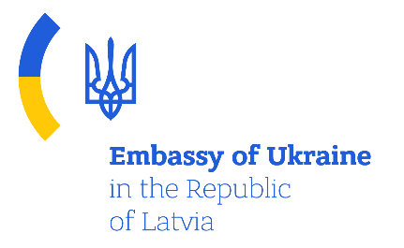
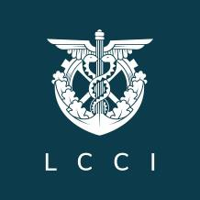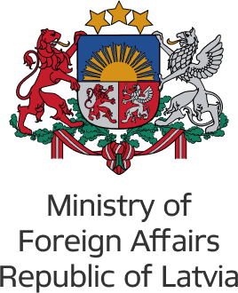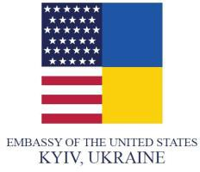

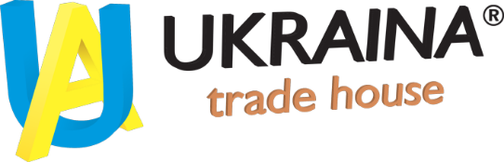
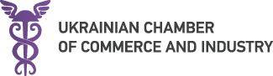
Support integration of Ukraine in to the Western and European single market by using Latvia as an entry point
Online training on specific EU and Latvia requirements for defined sectors
The WASTE RECYCLING and REWENABLE ENERGY sectors
Date: January 28, 2022
Platform: ZOOM
Working language: English, Russian

DRAFT PROGRAM

January 28, 2022
09:45 | Arrival of the participants and technical information
10:00 | Opening remarks  Mr. Mischenko Olexandr  Ambassador Extraordinary and Plenipotentiary of Ukraine to the Republic of Latvia
10:15 | Rewenable energy  Mr. Mārtiņš Zemītis  amats
11:00 | Wind energy sector  Mr. Toms Nāburgs  Managing director of “Latvian wind energy association”
11:40 | Sun energy sector (tbc)
12:10 | Waste recycling  Mr. Armands Nikolajevs  Executive director of " Latvian Association of Waste Management Companies "
12:40 | Eco Baltia (tbc)
13:00 | Getliņi (tbc)
13:40 | Q&A

The project is implemented with financial support from the U.S. Department of State Office of the Assistance Coordinator for Europe and Eurasia under the Eighth Round of the Development Cooperation Partnership (DCP) Program.

