SP-100 Mechanical Ventilator
SP-100 is a respiratory device designed for long-term mechanical ventilation, which can provide continuous or intermittent ventilation support for patients who need invasive or non-invasive mechanical ventilation.
SP-100 can be used in 7 different ventilation and breath mode combinations.
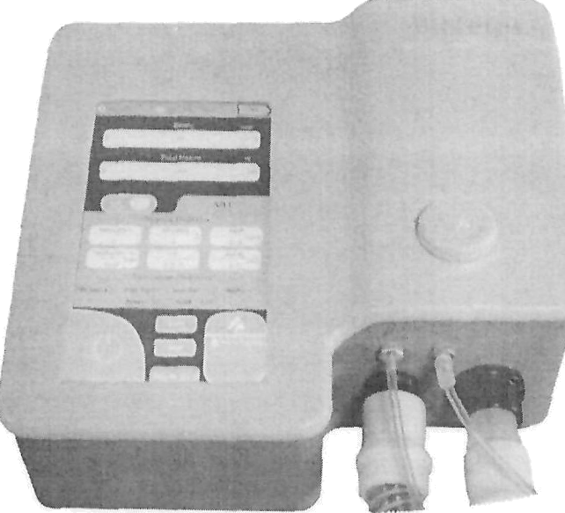

Figure 1: SP-J00 (intensive care and tiome)

Ventilation Modes A-PC, A-VC, SIMV-PC, SIMV-VC, PC, VC, CPAP/PSV
Inspiratory Pressurei 4-50 cmH20 Inspiration Time 0.3-5 s
I nspiratory Trigger 1-5
Rise Time 1-9
PEEP 0-30 cmH20
Number of Breaths 4 40
Tide Volume 50-3000 mL
Battery 16.8 V, 2.5A, 42W Li-ion
Screen 7.5” TFT Touch Screen
tVeight 4,6 kg
Dimension 33x33x18 cm

Table 1: £echnico/ Properties Sfiort Notes

- A PC - Auxiliary Pressure Controlled Ventilation
- PC - Pressure Controlled Ventilation
- SIMV-PC - Pressure Controlled with Synchronized Intermittent Mandatory Ventilation
- A-VC - Auxiliary Volume Controlled Ventilation
- VC - Volume Controlled Ventilation
- SIMV-VC - Volume Controlled with Synchronized Intermittent Mandatory Ventilation
- CPAP / PSV - Continuous Positive Airway Pressure / Pressure Assisted Ventilation Technical Specifications
Breathing Mode | A-PC, A-VC, SIIVIV-PC, SIMV-VC, PC, VC, CPAP / PSV
Breathing Circuit | Dual Line
PEEP | 0-30 cmH2O
Rise Time | 1-9
Inspiratory Trigger | 1 5
Inspiratory Time | 0.3 5 s
Number of Breaths | 4 40 breaths (1 minute intervals per minute)
Patient Pressure | 4-S0 cmH20
Tide Volume | 50-3000 mL
Alarms | High pressure, Low Pressure, Apnea Time, Mains voltage,  Built-in battery, High tidal, Low Tidal, High Minute Volume, Low Minute Volume, Patient Connection, High BPM, Low BPM
Apnea Time | can be adjusted between 0-60 seconds
display | 7.5 inch Colo r Touch Screen
Internal Battery | 16.8 Volt, 2.5A, 42W
Configuration and Control | Adjustment with Colo r Touch Screen and Rotary Button
Classification | II
Current Protection | BF
Storage Conditions | 20°C / 60°-C, 15% -95%, 700hPa-1060hPa
Operation Conditions | 5°-C / 40°C, 15% -95%, 700hPa-1060hPa
Electrical characteristics | 185-240V / 50-60Hz / 3A Fuse / 77VA
Physical Properties | 4.6kg  33X33 X18cm
Electrical safety & EMC | Conforms to IEC 60601-1 and IEC 60601-1-2
Warranty | 2 years
IEC 60601-1 Classification | Number of Poles: 1  Declared Voltage (Un): 185-240 VAC  Declared Operating Voltage (Ue): 185-240 VAC Declared Current (In): 1.5 A  Declared Frequency (fn): 50-60 Hz Fuse: 3A  Type of protection against electric shock: Class II Degree of protection against electric shock: Type BF  Declaration protection degree against impacts and water: IP 21

Table 2: SP-TOO £erhnico/ Properties

